

Big data Management

Assignment

Jeyadev L

G23AI2071

# Connection to Redis

# Reading Data from CSV and TXT files

# Write Function to Redis.

I use pandas dataframe to write into Redis which eliminates the need to specify any data type or schema

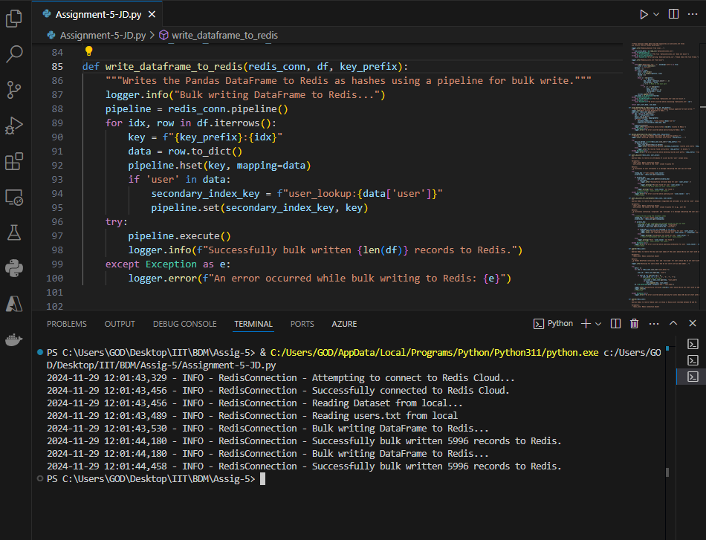

# Query 1

# Query 2

# Query 3

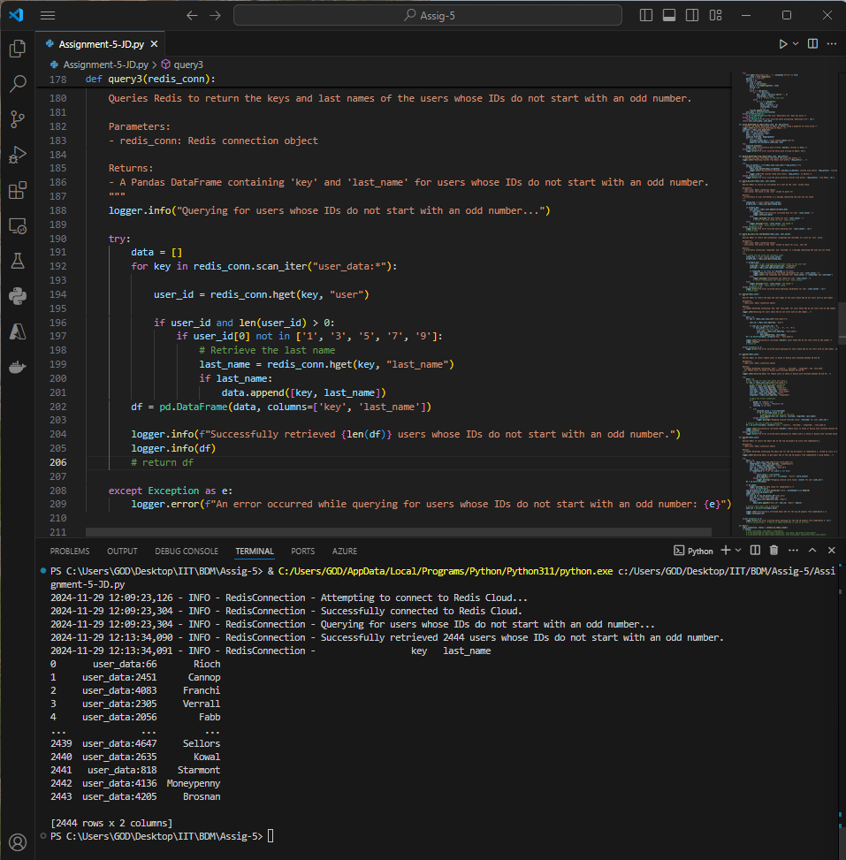

# Query 4

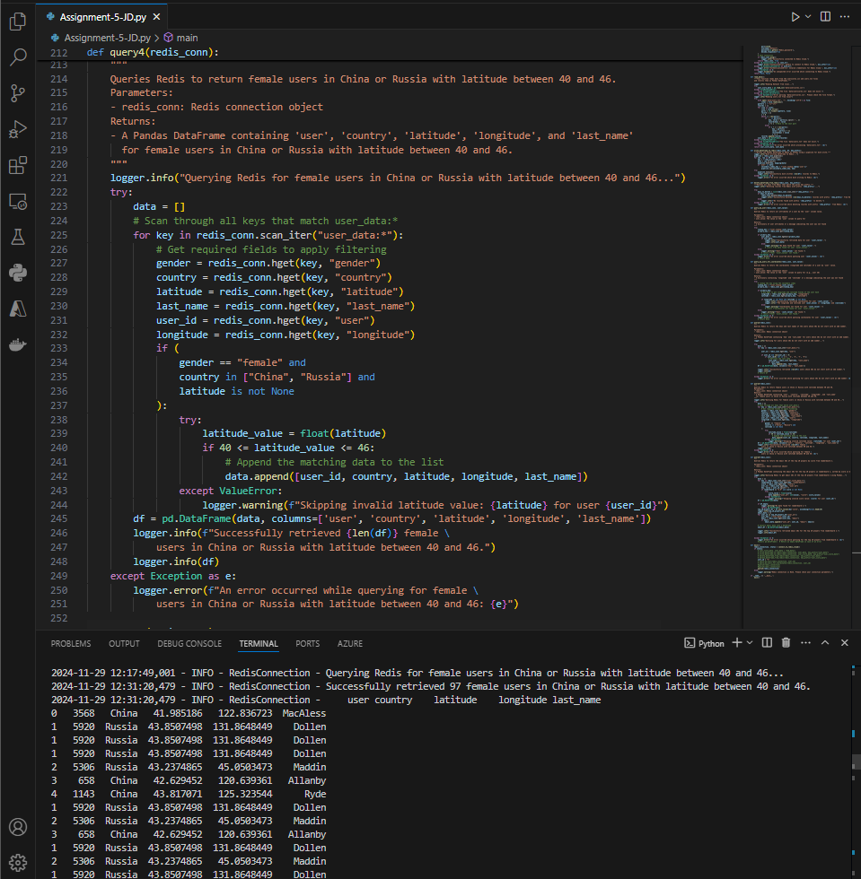

# Query 5

